

Logic Apps & WebJob

Author: Tyler Lu

Contents

1. Logic Apps 2

1.1. Create App registrations in AAD 2

1.2. Deploy Logic Apps 2

1.3. Add Redirect URL 5

1.4. Authorize planner and teams API Connections 5

1.5. Authenticate Microsoft graph API Connection 6

1.6. Get Logic App URLs 7

2. WebJob 9

2.1. Build and create the WebJob package 9

2.2. Add App settings 9

2.3. Create storage account and add connection strings 10

2.4. Add WebJob 10

# Logic Apps

## Create App registrations in AAD

1. Navigate to the Huddle AAD you want register the app to.
2. Create an App Registration in AAD with the following settings:

* **Name**: Huddle MS Graph Connector
* **Application Type**: Web app/API
* **Sign-on URL**: https://<Your Domain>/ms-graph-connector
* **Required Permissions**:

|  |  |
| --- | --- |
| API | Permissions |
| Microsoft Graph | Delegated Permissions:   * Read and write all groups * Read all users’ full profiles |

1. After the App Registration created:

* Copy aside the Application ID. It will be used as the value of **Aad Client Id** parameter when deploying the ARM Templte.
* Create a new key, and copy aside its value. The value will be used as the value of **Aad Client Secret** parameter when deploying the ARM Template

Note: Keep the AAD registration open, we will add a Reply URL later.

## Deploy Logic Apps

1. Open <https://portal.azure.com/#create/Microsoft.Template>, and sign in with the work account you deployed the Bot and Metric App.

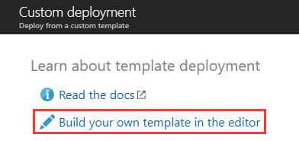

1. Click **Build your own template in the editor**.

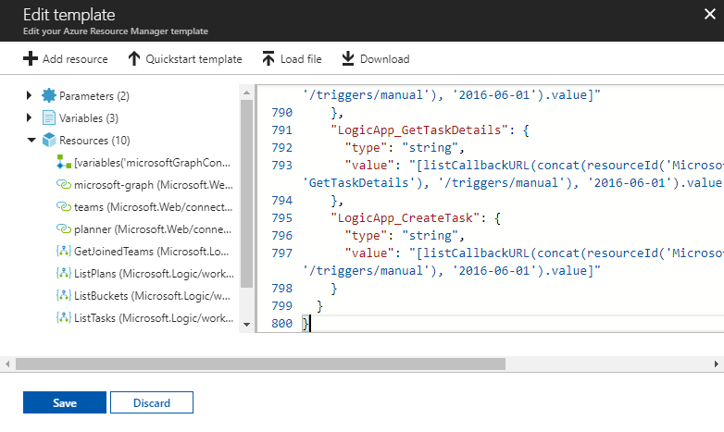

Open */Files/LogicApps.json*, then copy its content into the template editor.

Click **Save**.

1. Fill in the form below:

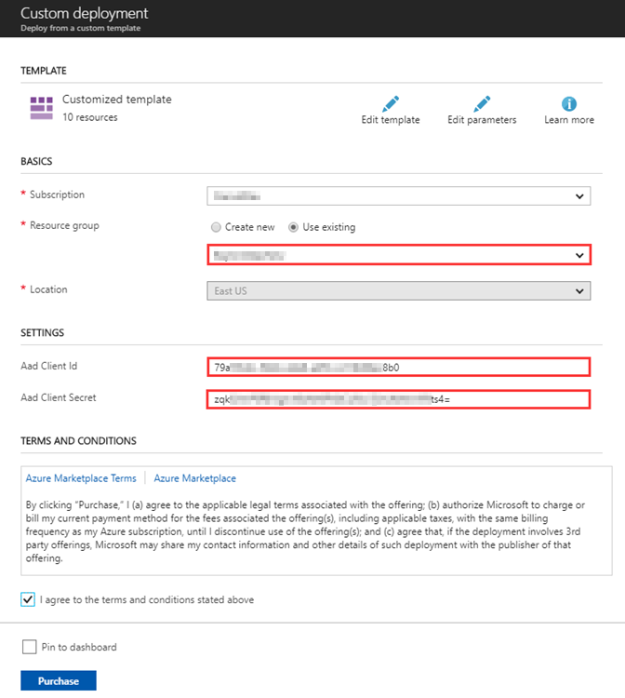

* 1. Select the **resource group** you deployed the Bot and Metric Web Apps. Creating a new resource group is OK.
  2. Input the **Aad Client Id** and **Aad Client Secret**: use the values you got from previous section.
  3. Check **I agree to the terms and conditions stated above**.
  4. Click **Purchase**.

## Add Redirect URL

1. Click the Microsoft Graph Logic Apps Connector



Note: In your resource group, the name suffix is different.

1. Click Edit.

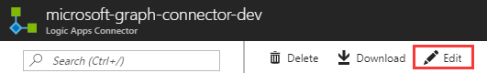

1. Click **Security**.

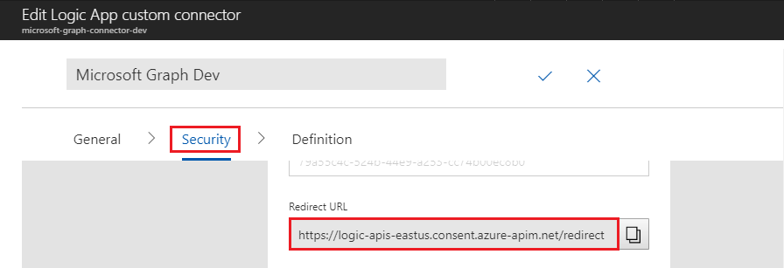

Copy the **Redirect URL**.

1. Add the Redirect URL to Reply URLs of the MS Graph App Registration.

## Authorize planner and teams API Connections

Go to the resource group.



Following the steps below to authorize the **planner** API Connection.

1. Click the planner API Connection.

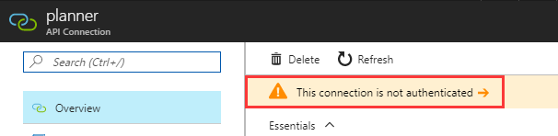

1. Click **This connection is not authenticated**.

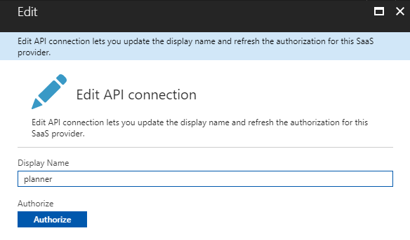

1. Click **Authorize**.

Pick up or input the Huddle user account mentioned in *1. Overall*. The user account should be every teams.

Sign in the account.

1. Click **Save** at the bottom.

Following the similar steps to authorize the **teams** API Connection.

## Authenticate Microsoft graph API Connection



Due to some unknown reason, we can authorize the **microsoft-graph** API Connection as above. Please use the steps below instead.

1. Click **ListPlans** Logic App



1. Click **Edit**

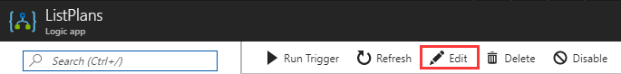

1. Click **Connections** to expand it, then click **Invalid connection**.

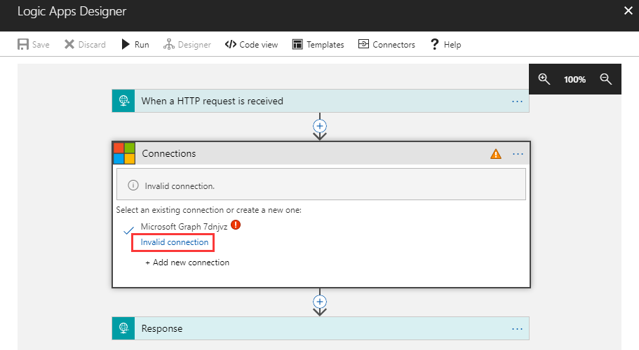

1. Pick up or input the Huddle account used to authorize planner and teams API Connections, then sign in.

## Get Logic App URLs

1. Go to the resource.
2. Search and click **Deployments**.

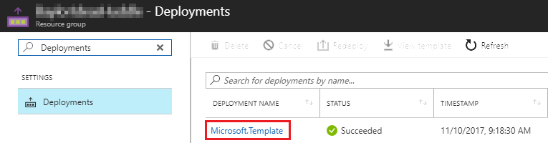

1. Click the template.

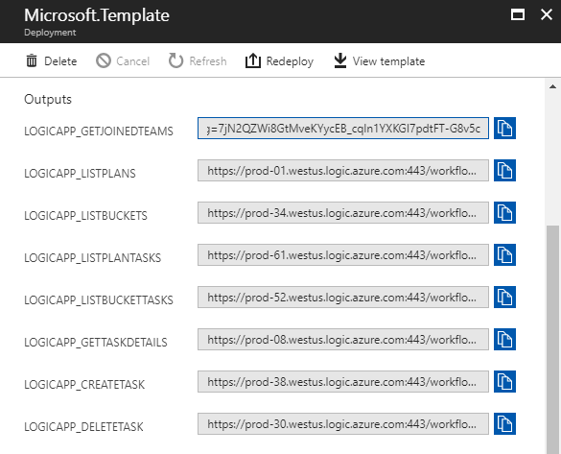

The values in Output section will be used as values of app settings. Keep the page open.

# WebJob

## Build and create the WebJob package

Build *Huddle.WebJob* project in release mode. Open its /bin/Release folder in file explorer, then zip all files.

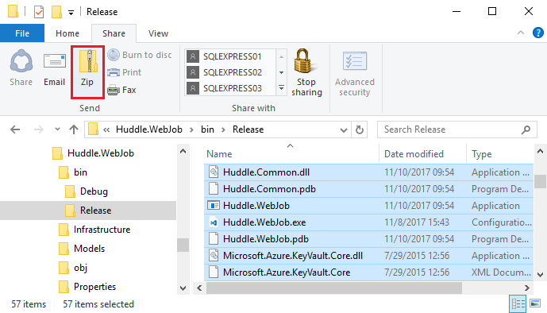

Rename the zip file “HuddleWebJob”.

## Add App settings

Open the Metric Web App you deployed in a new tab or window. Add the following App settings.

|  |  |
| --- | --- |
| Key | Value |
| GlobalTeam | Name of the global Team |
| LogicApp_GetJoinedTeams | Get the corresponding values from the Outputs of the deployment result |
| LogicApp_ListPlans |
| LogicApp_ListBuckets |
| LogicApp_ListPlanTasks |
| LogicApp_ListBucketTasks |
| LogicApp_GetTaskDetails |
| LogicApp_CreateTask |
| LogicApp_DeleteTask |

## Create storage account and add connection strings

Create a storage account and add the following connection strings

|  |  |  |
| --- | --- | --- |
| Name | Value | Type |
| AzureWebJobsStorage | Connection string of the storage account | Custom |
| AzureWebJobsDashboard | Custom |

## Add WebJob

Add a WebJob to the Metric Web App

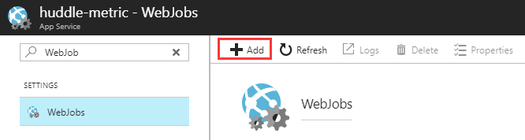

Use the following settings:

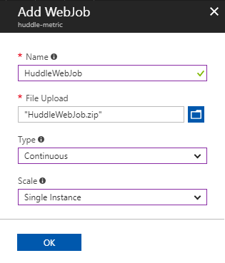

* Name: HuddleWebJob
* File Upload: select *HuddleWebJob.zip*
* Type: Continuous
* Scale: Single Instance

Click **OK**.